1. Create a new unity project

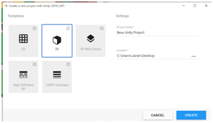

1. Create 3 cubes

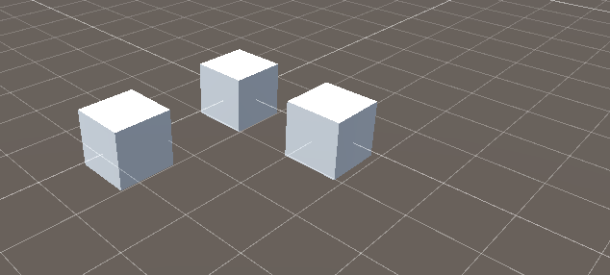

1. Leave 2 of your choice as they are.
2. Stretch out the third cube to make a platform.

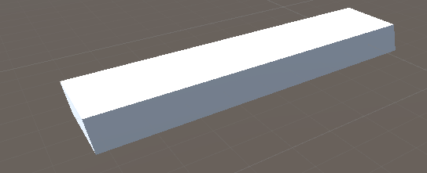

1. We stretch out this platform using the scale tool

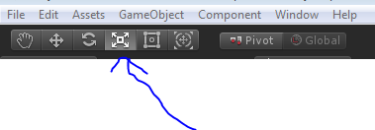

1. Put the other two cubes on the platform

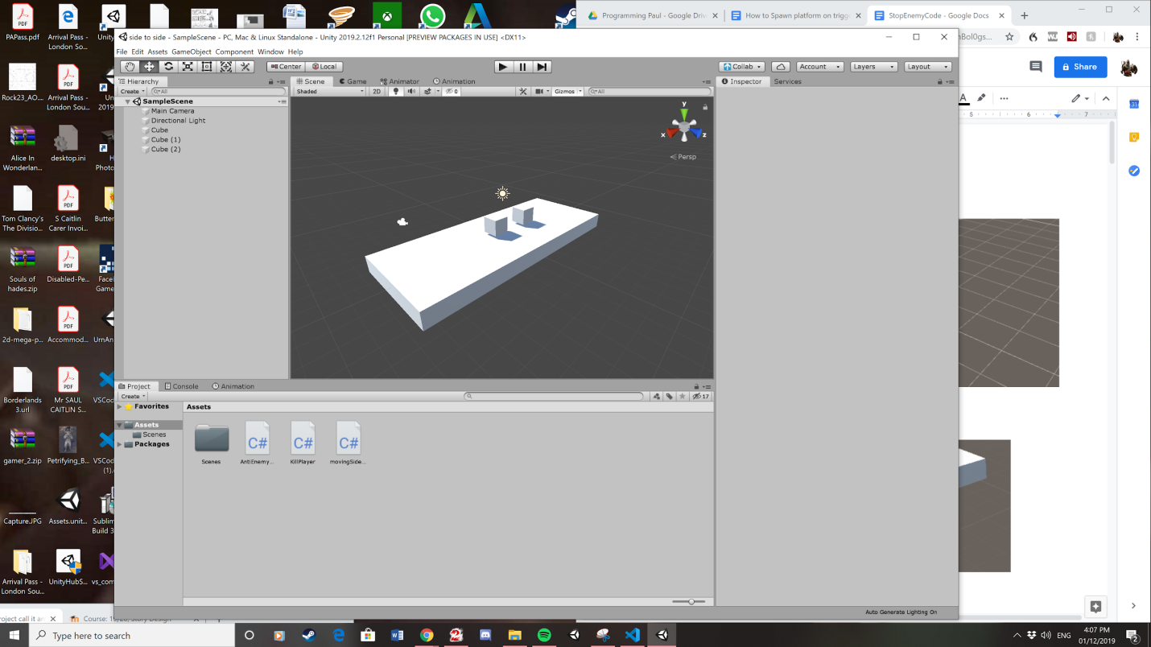

7. Change the tag of one of the cubes to player. By clicking on the cube opening the inspector, when you are in the inspector click on where is says tag. Select from the list of tags and click on Player.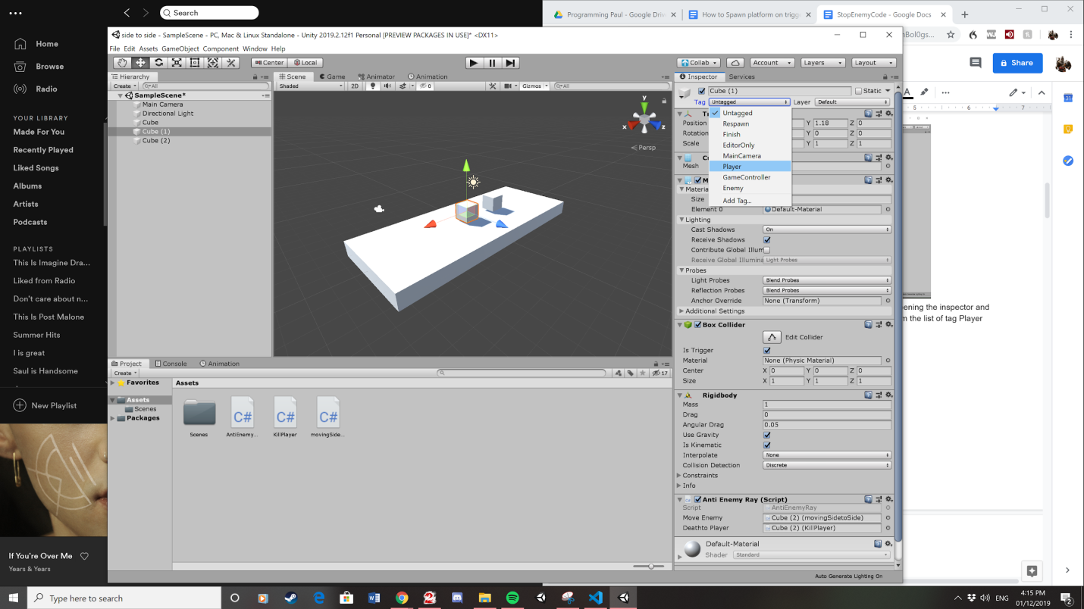

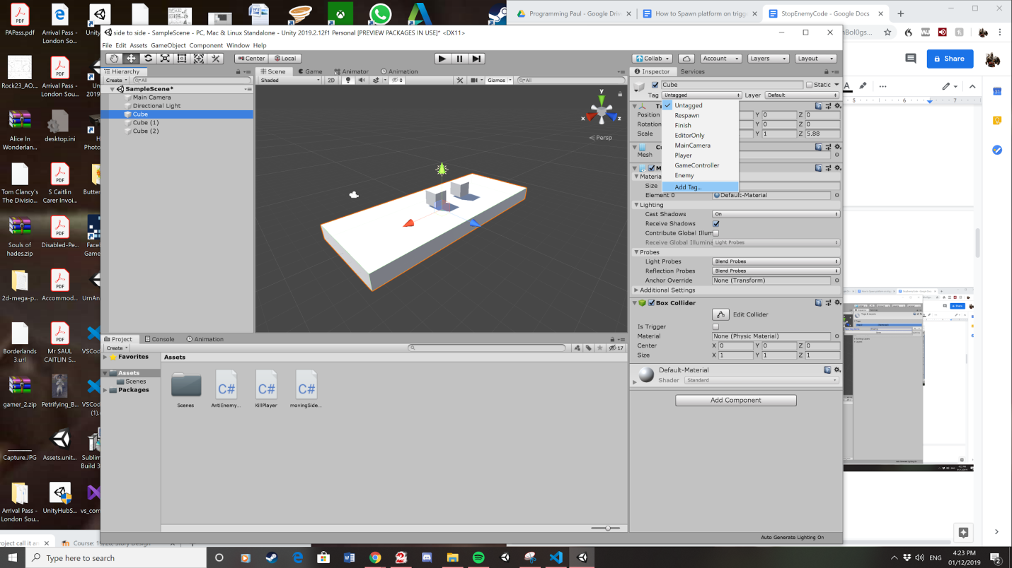8. Create a new tag by going into the tag and select add tag.

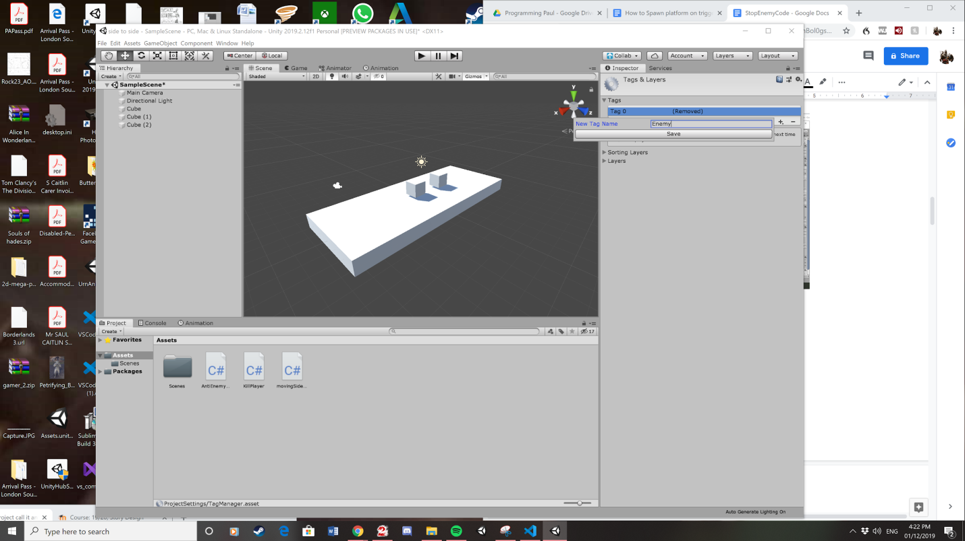

9. Change the tag of the remaining cube to enemy.

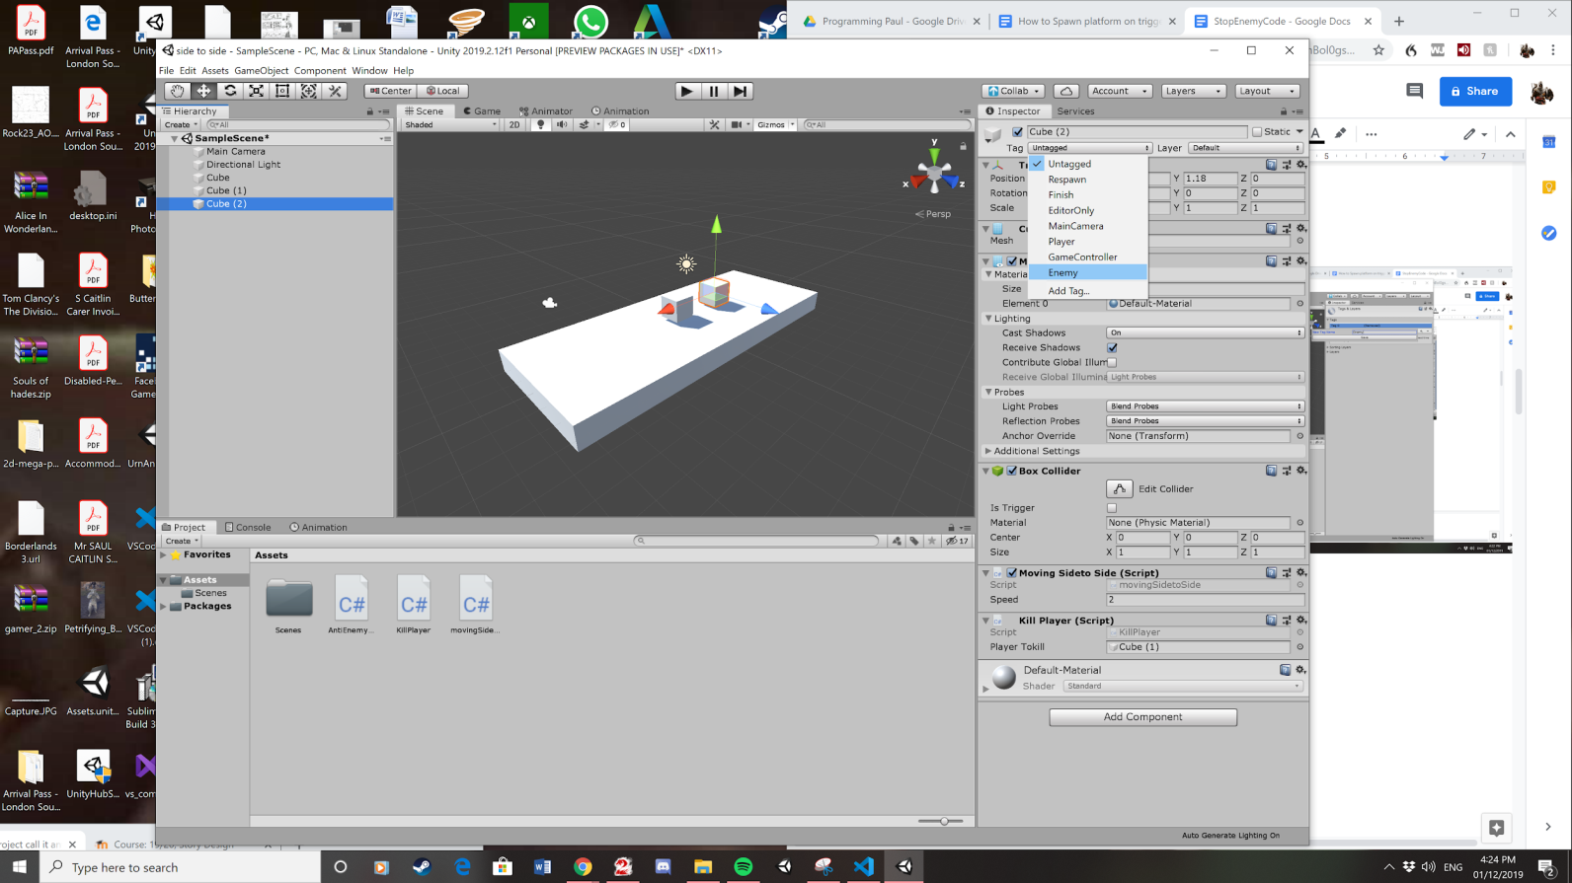

10. Create a new Script

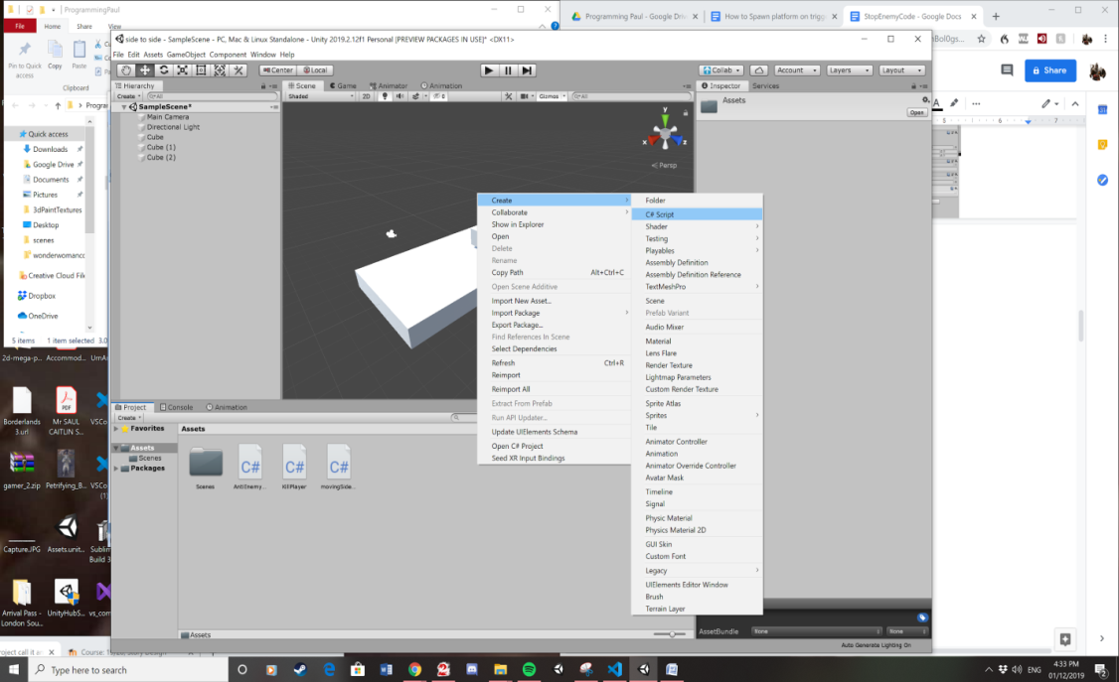

11. Rename it to moving side to side.

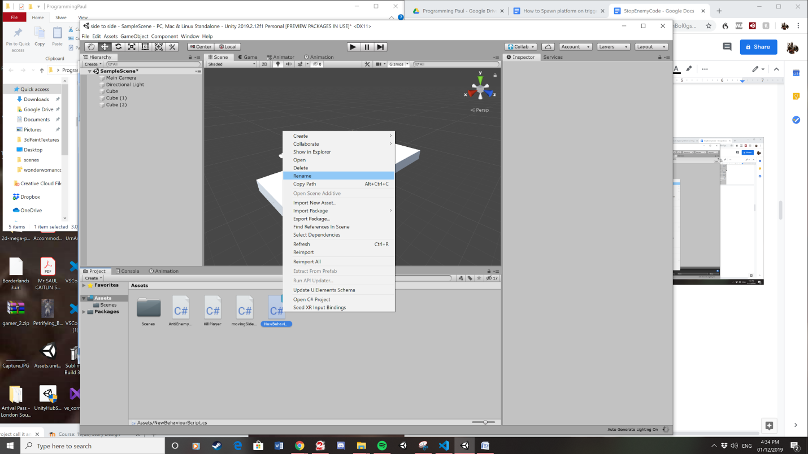

12. Here is what it should look like.

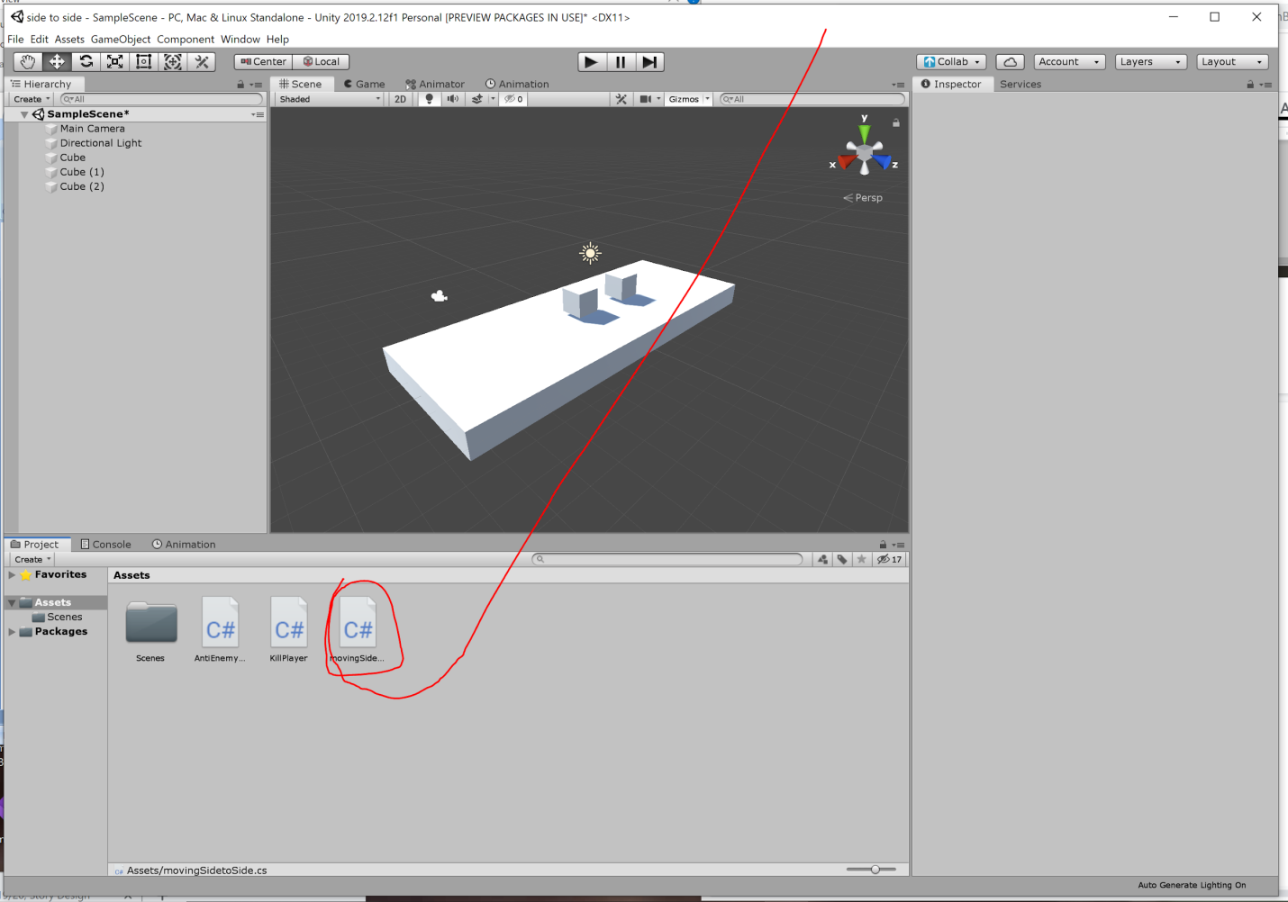

13. Open script by left clicking it. This opens visual studio code.

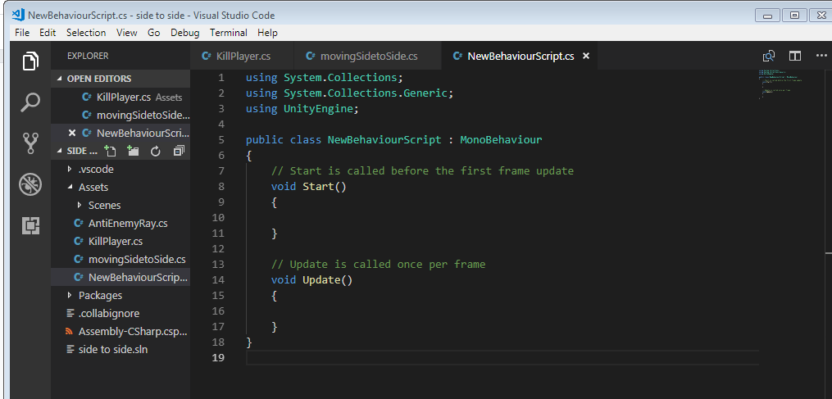

14. Add this code into visual studio code. Copy all of this code expect public class moving

using System.Collections;

using System.Collections.Generic;

using UnityEngine;

public class movingSidetoSide : MonoBehaviour

{

private bool dirRight = true;

public float speed = 2.0f;

void Update () {

if (dirRight)

transform.Translate (Vector2.right \* speed \* Time.deltaTime);

else

transform.Translate (-Vector2.right \* speed \* Time.deltaTime);

if(transform.position.x >= 4.0f) {

dirRight = false;

}

if(transform.position.x <= -4) {

dirRight = true;

}

}

}

15 .Drag the side to side movement script to the Enemy game object

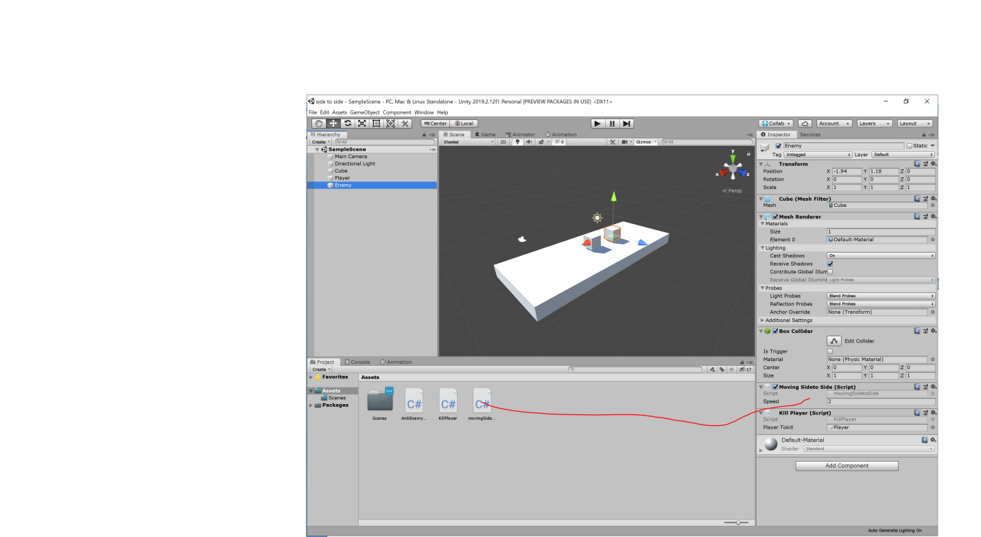

16. Create a script.

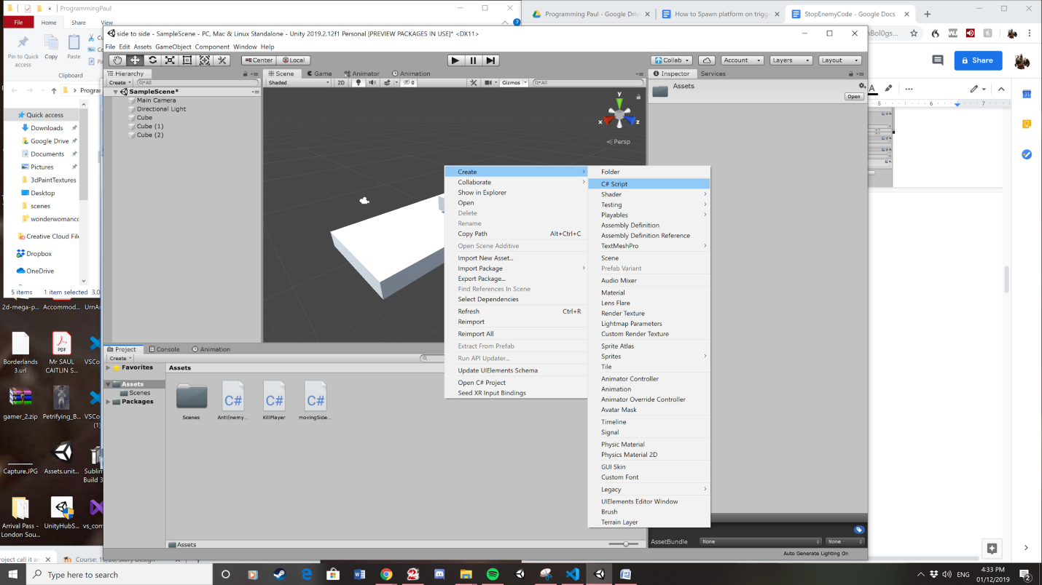

17. Rename it to kill player.



18. This is what it should look like.

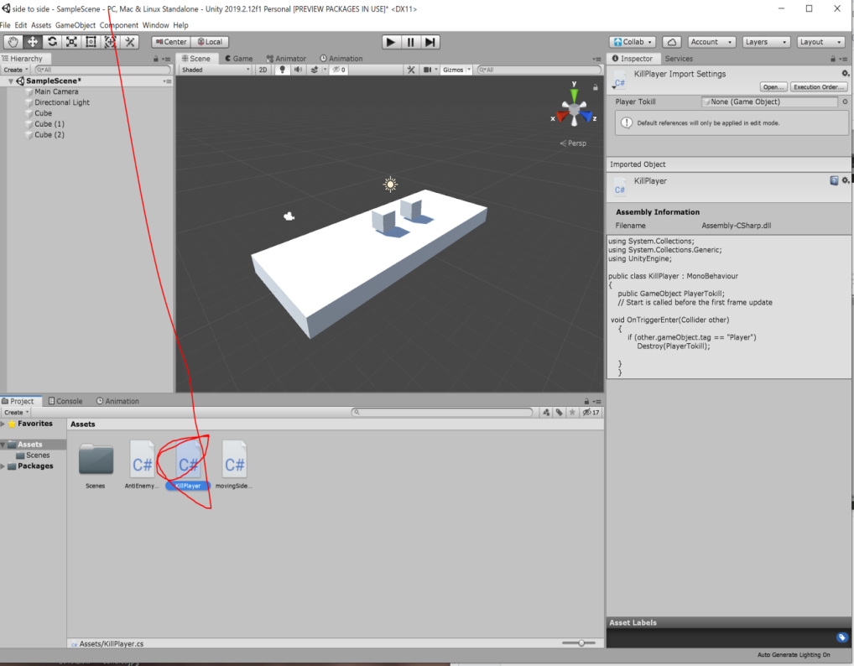

19. Open the script opening visual studio code. 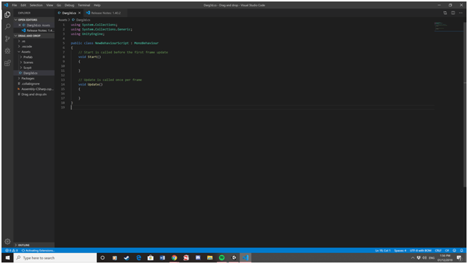

20. Add all of this code expect public class kill player.

using System.Collections;

using System.Collections.Generic;

using UnityEngine;

public class KillPlayer : MonoBehaviour

{

public GameObject PlayerTokill;

// Start is called before the first frame update

void OnTriggerEnter(Collider other)

{

if (other.gameObject.tag == "Player")

Destroy(PlayerTokill);

}

}

21. Put this script on to the enemy game object.

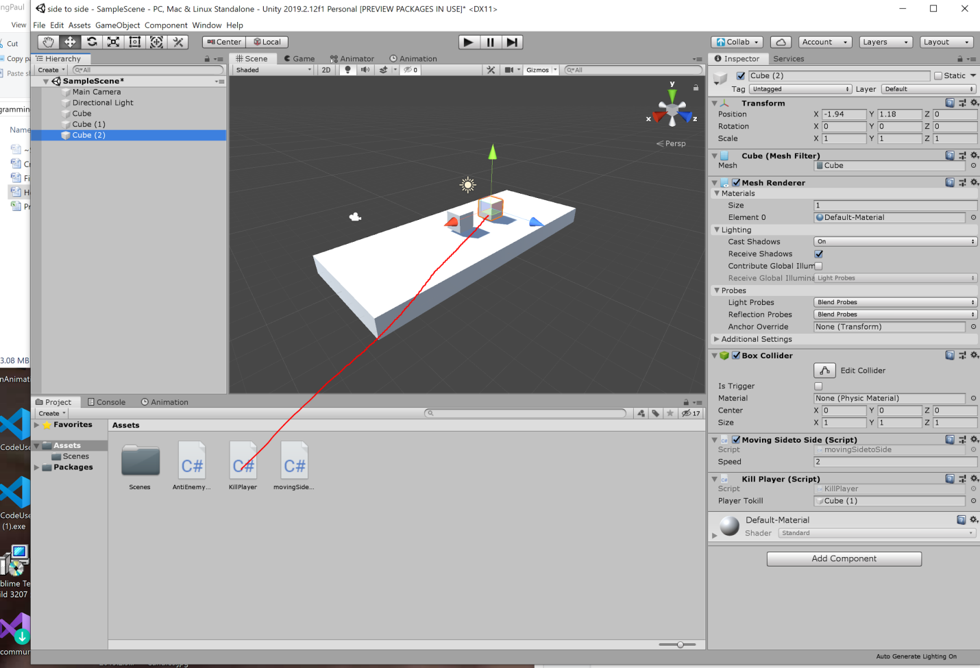

21. Then drag the player game object on the kill player Script.

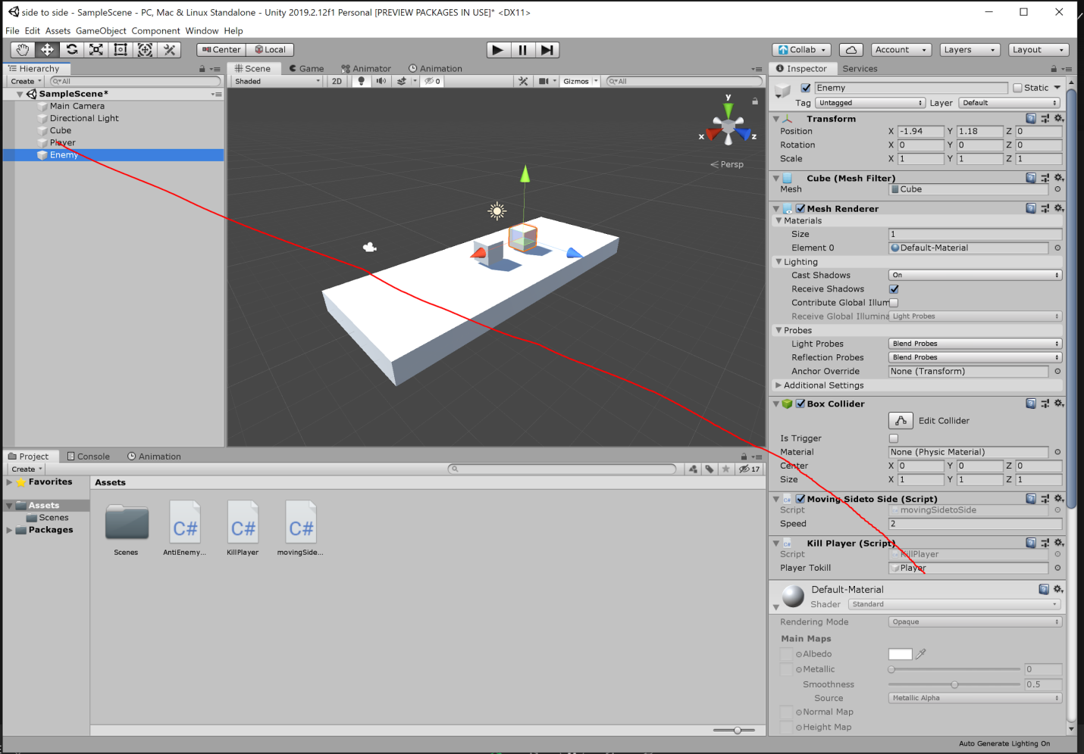

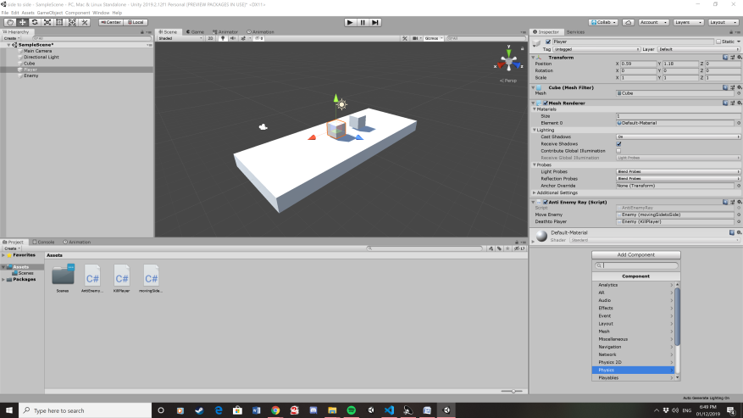23. Add a box collider on to the player by clicking on add component. Then select phicsy and pick box collider

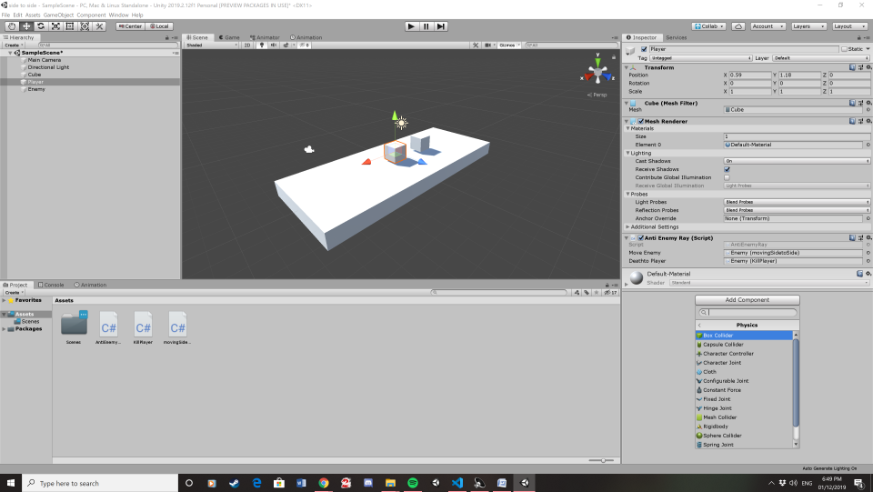

24. Click on is trigger on the box collider.

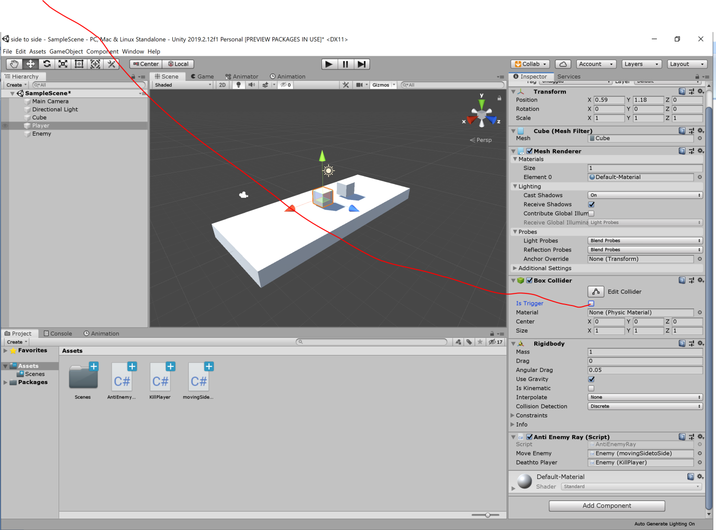

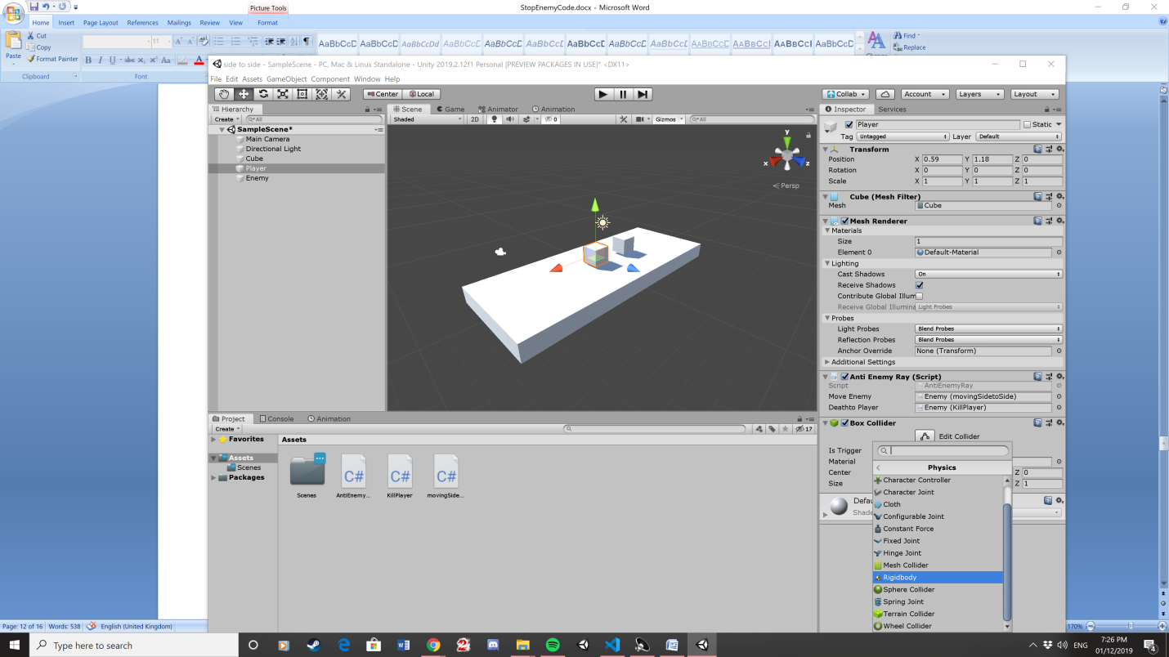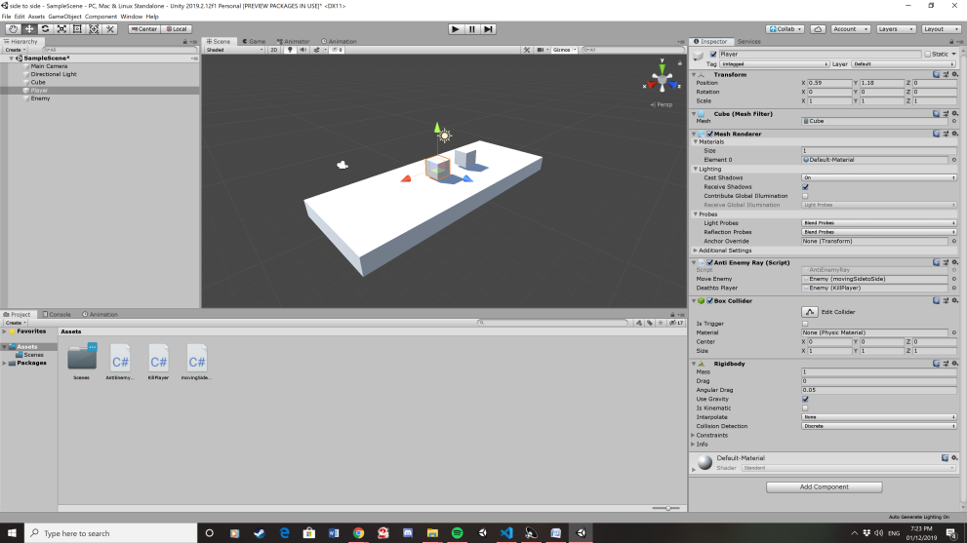25. Add a rigid body on to the player by clicking on add component. Then select physics and pick rigid body.

26. Click on Is Kinematic

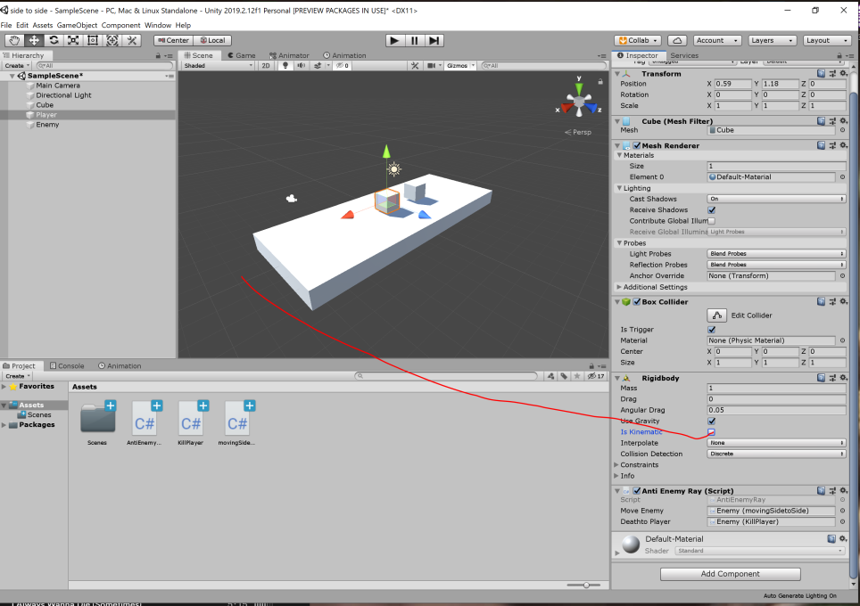

27. Create a Script

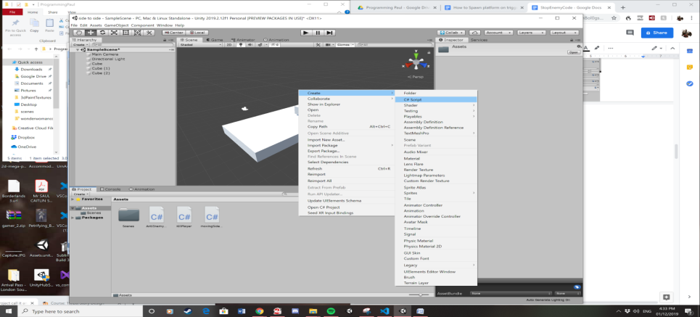

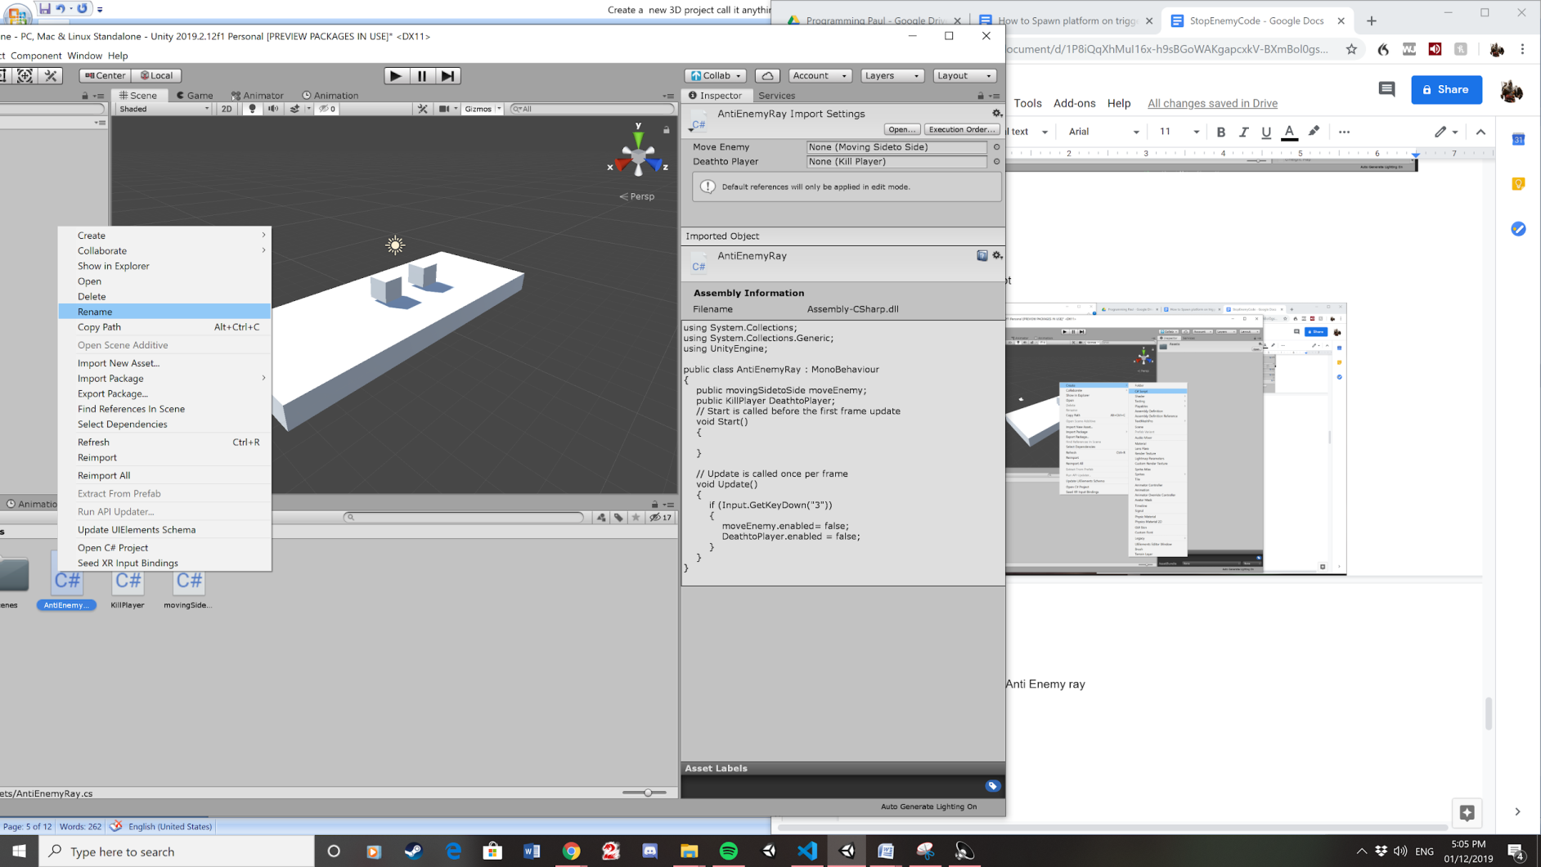

28. Rename it to Anti Enemy ray.

29. Open the script by left clicking on it. This Opens Visual studio code.



30. Add this code to visual studio code. Copy Everything except public AntiEnemyRay. This will be used to disable the enemy’s script.

using System.Collections;

using System.Collections.Generic;

using UnityEngine;

public class AntiEnemyRay : MonoBehaviour

{

public movingSidetoSide moveEnemy;

public KillPlayer DeathtoPlayer;

// Start is called before the first frame update

void Start()

{

}

// Update is called once per frame

void Update()

{

if (Input.GetKeyDown("3"))

{

moveEnemy.enabled= false;

DeathtoPlayer.enabled = false;

}

}

}

30.drag script onto player game object.

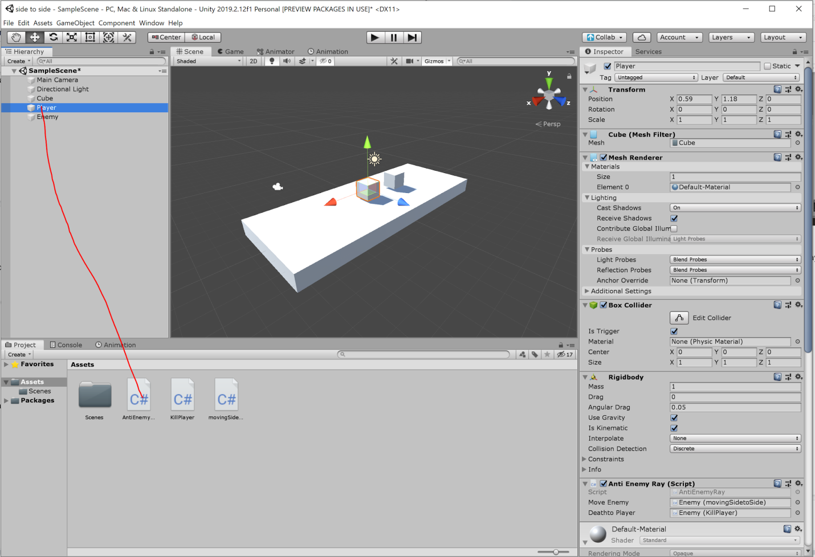.

31. Then drag both kill player and moving side to side scripts to anti enemy ray.

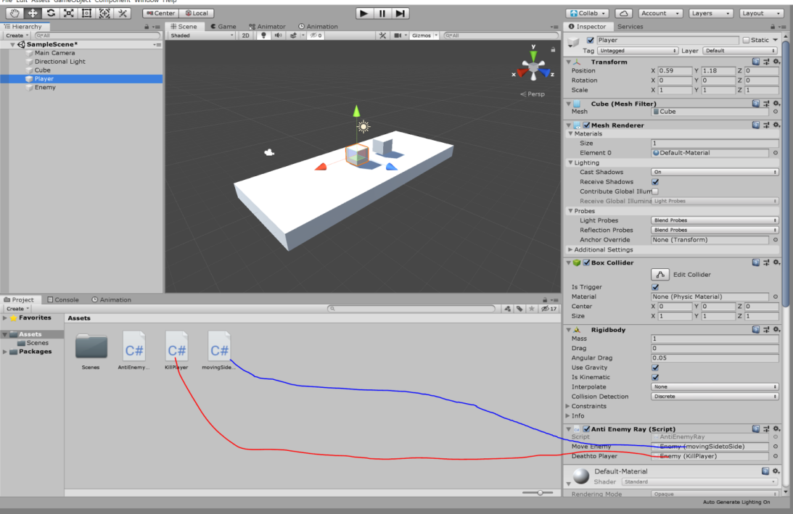

32. Well done you have completed the tutorial and will have a project that has a cube that can kill the player as well as the player being able to disable the enemy’s Script.

33. Press the play button on unity which will make all the code work.

